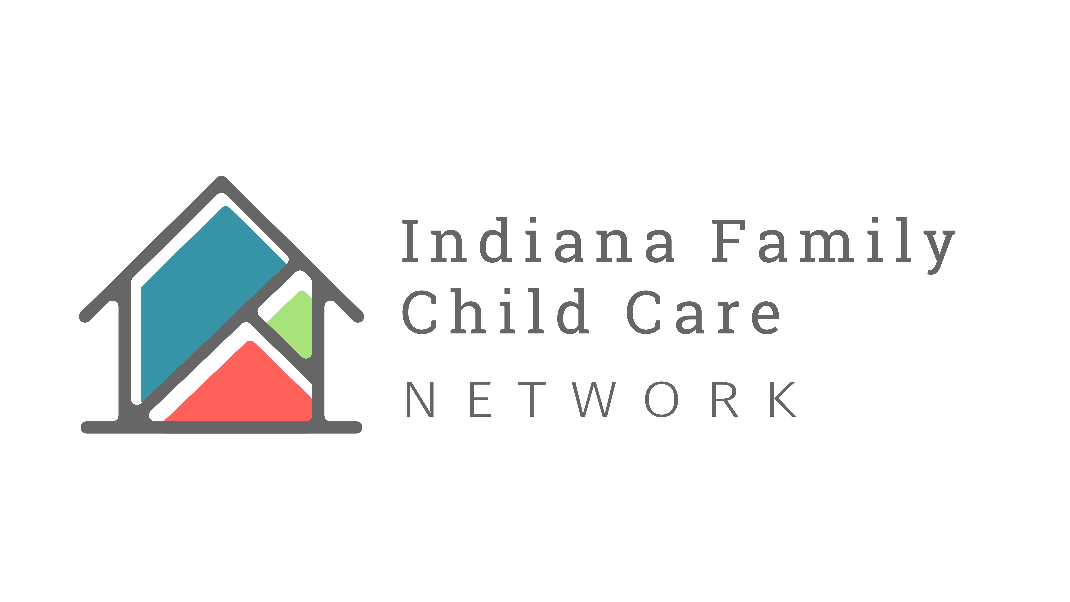
This letter serves as your receipt for tax purposes. [Organization Name] is a 501(c)(3) not for profit, tax-exempt organization (tax
ID ###). No goods or services were exchanged for your contribution.
[DATE]

Dear [Donor First Name],

Thank you! You make a difference.

We appreciate [Organization Name] support of Indiana’s Family Child Care Network

You are helping early childhood educators in your community access vital state and local resources, along with business best practices that support their professional growth; ultimately improving the accessibility and affordability of early childhood education for families in your community

Thank you again for your generosity and commitment to the youngest Hoosier children and their bright futures.

Sincerely,

[Name]
[Title]
[email]

Eligible amount for tax purposes:
[Dollar Amount]

Gift Date:
[Date]

Designation(s):
[Type of Donation]

Your generosity helps empower providers and serve families in need.

